Data Acquisition and Pre-processing

1.1.1 Data Cleaning and Pre-processing using Pandas and Numpy
Data cleaning is the process of correcting or removing incorrect, corrupted, incorrectly formatted, duplicate, or incomplete data. This is the first step in any data analysis project.
Sample CSV (data.csv):
Name,Age,Gender,Salary
Alice,25,Female,50000
Bob,,Male,55000
Charlie,30,,60000
David,28,Male,
Eve,25,Female,52000
Alice,25,Female,50000
Python Code:
import pandas as pd
import numpy as np
df = pd.read_csv('data.csv')
df['Age'].fillna(df['Age'].mean(), inplace=True)
df['Gender'].fillna(df['Gender'].mode()[0], inplace=True)
df['Salary'].fillna(df['Salary'].mean(), inplace=True)
df.drop_duplicates(inplace=True)
df['Age'] = df['Age'].astype(int)
df['Salary'] = df['Salary'].astype(int)
print(df)

1.2.1 Summary Statistics and Descriptive Analysis
Descriptive analysis summarizes data using measures like mean, median, mode, variance, standard deviation, and frequency distributions.
Box plot of salary by gender:
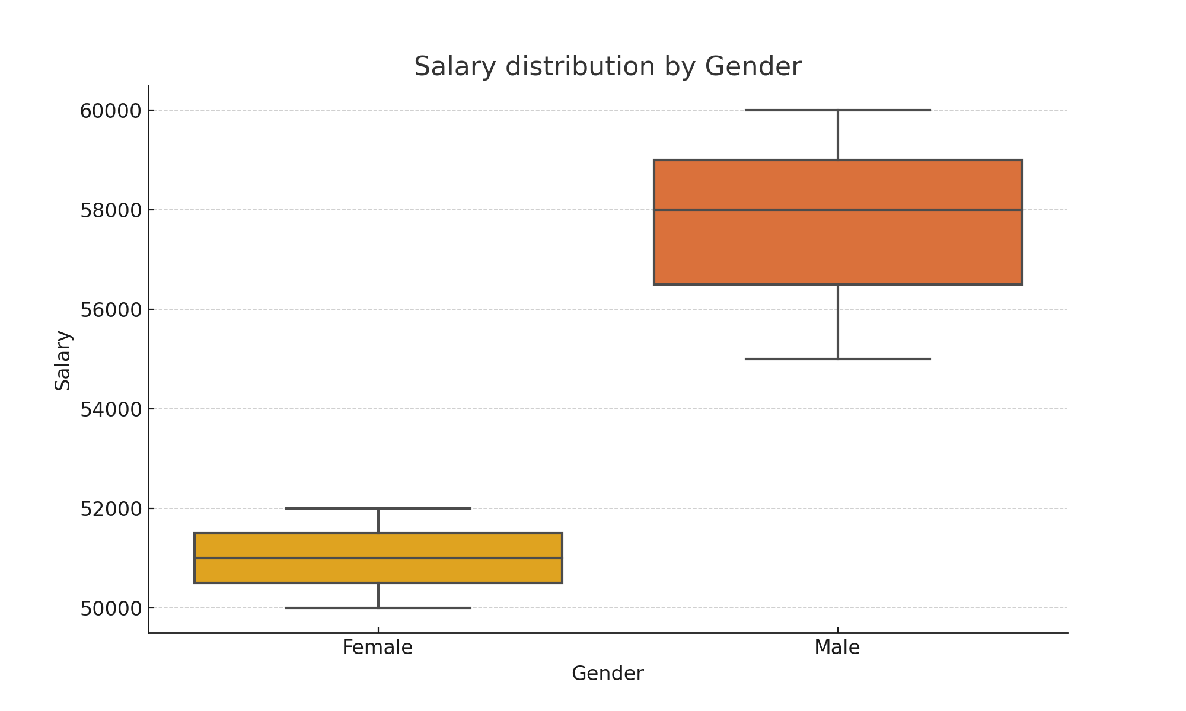
Histogram of Age:
